Analysis:

Base Case Analysis: This analysis is for a slow weekday, since that is when the data was collected; where the food line’s open hours are from 11-2. The alternative methods were determined from the results of the base case analysis for the slow week day situation.

Note: The food line schedule from open to close is from 11-2 which is 3 hours or 10800 seconds, the analysis is for the time the food line is open, the barista and cashier remain longer and this is not analyzed in the program. A slow “regular day” is sometime during the week without a large group coming in.

The number of people that go through the system during this time is 355

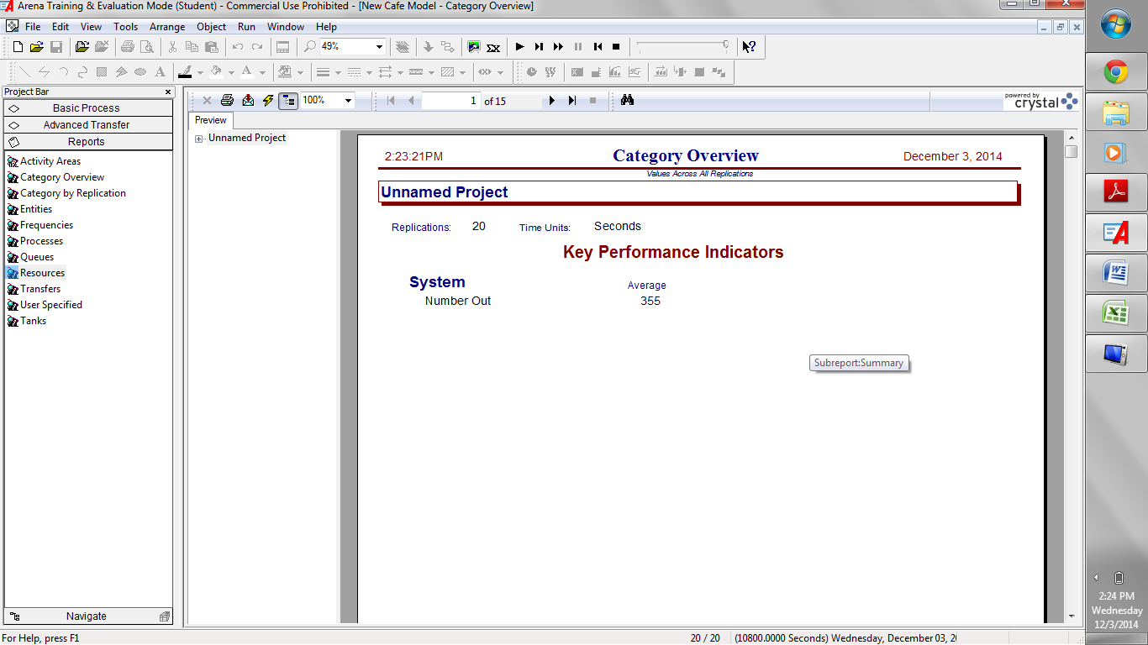

The total time a customer spends in the system as a whole is 1251.57 seconds or 20.8595 minutes, this time is within a 95% confidence interval, where based on the half width, the upper CI is at 1298.57 and the lower CI is at 1213.67.

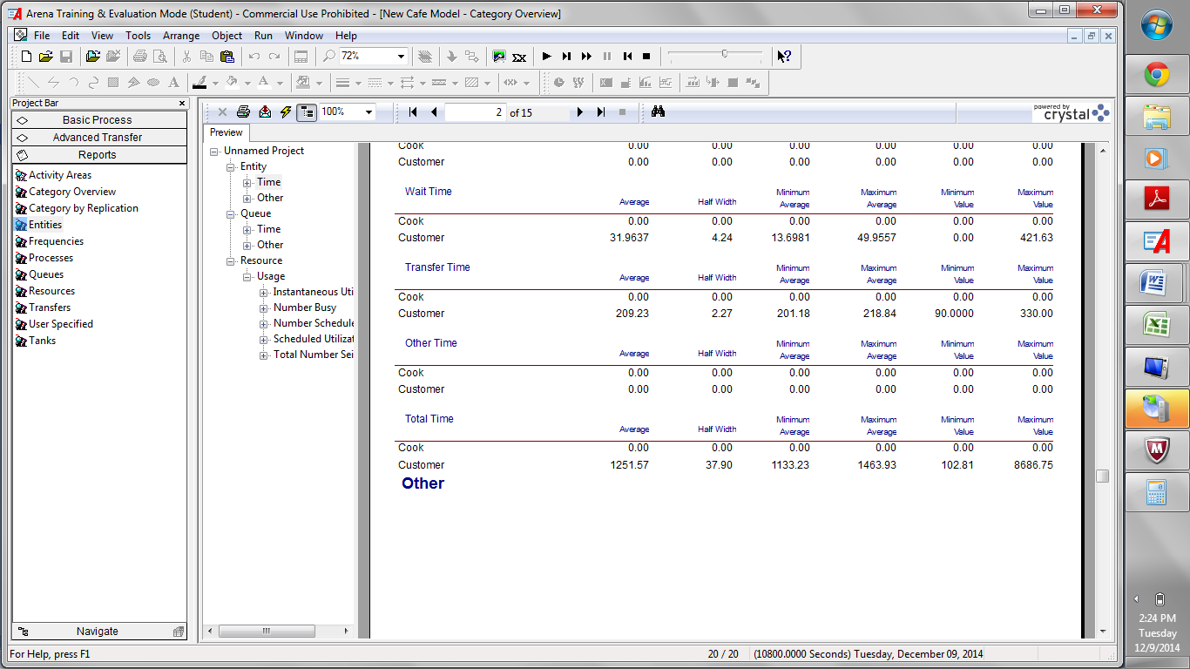

As we can see the Food Service Time Queue is almost negligible, the time people spend waiting is at 1 second during a slow Monday, which leads to a possible alternative, having only 1 server present. This queue time means that the food line is extremely efficient, leaving people little to no wait to order.

The Cash Register Queue Time is also very small on a slow day. The average queue time is said to be only 5 seconds to be served.

The longest time a person will spend waiting will be cashing out or getting a special order from the barista. So a possible solution to reduce the waiting time would be to add a bar cashier to reduce time.

Similarly to the total time confidence interval we can look at the half width and add it and subtract it from the average to be 95% sure that the queue length will be a certain time.

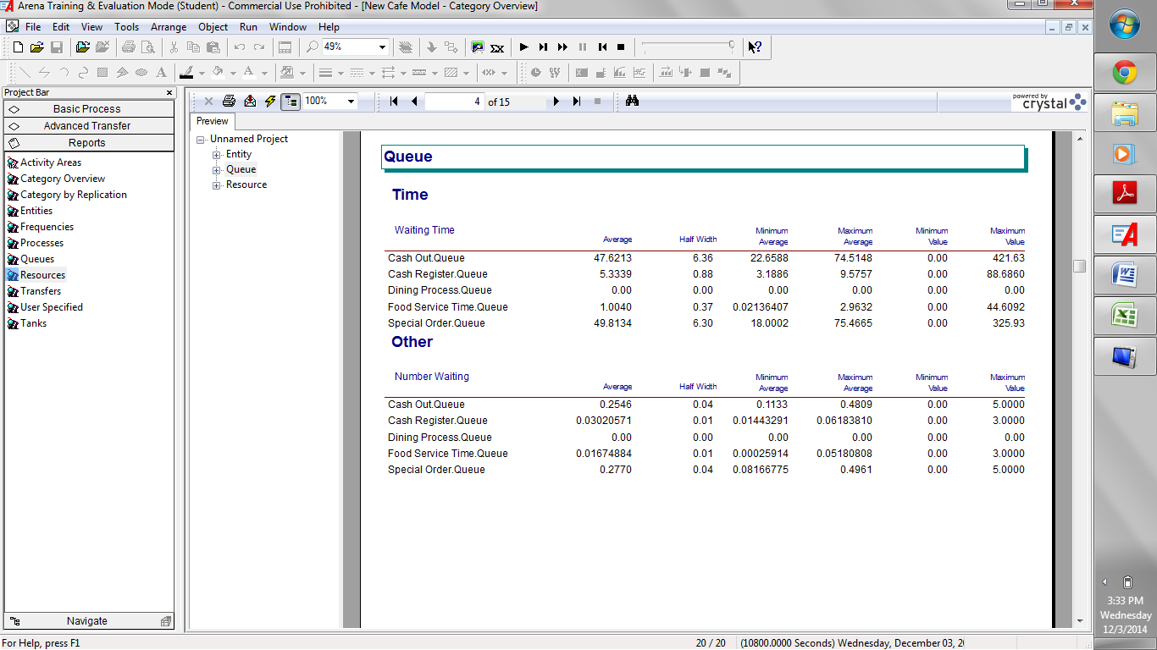

Final Report Analysis, there is little need for improvement on this system since it is very efficient, waiting times are very small, and there are very little customers that end up leaving without getting an item. If the goal is to reduce the total cost for the Best Café for the museum, a possible alternative would be to reduce the number of food servers during a slow day, i.e. have one food server working the slow day rather than two.

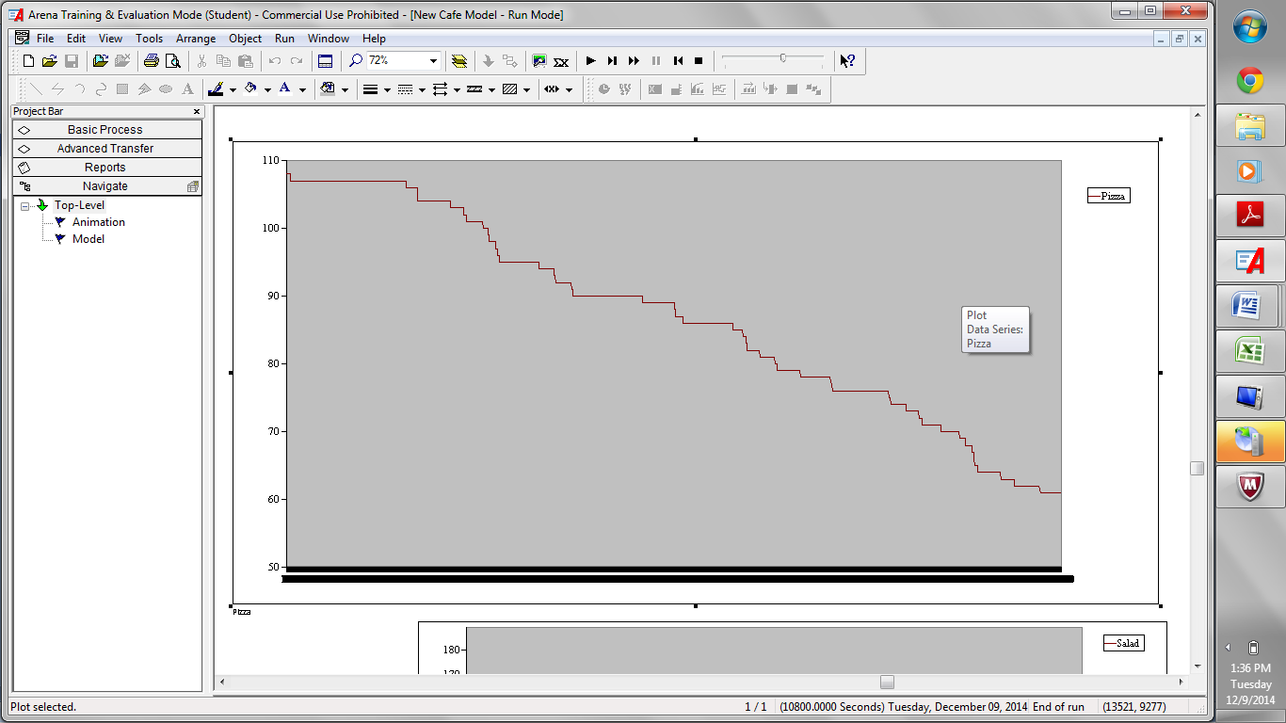

We can see that on a slow Monday, if we have the full amount of pizza servings, meaning a full rack, we never run out of pizza, in fact there is just above 60 servings left for the next day. This number is solely based on the number of pizza servings not counting the number of pizzas that get burnt or thrown away due to mistakes, or expiration.

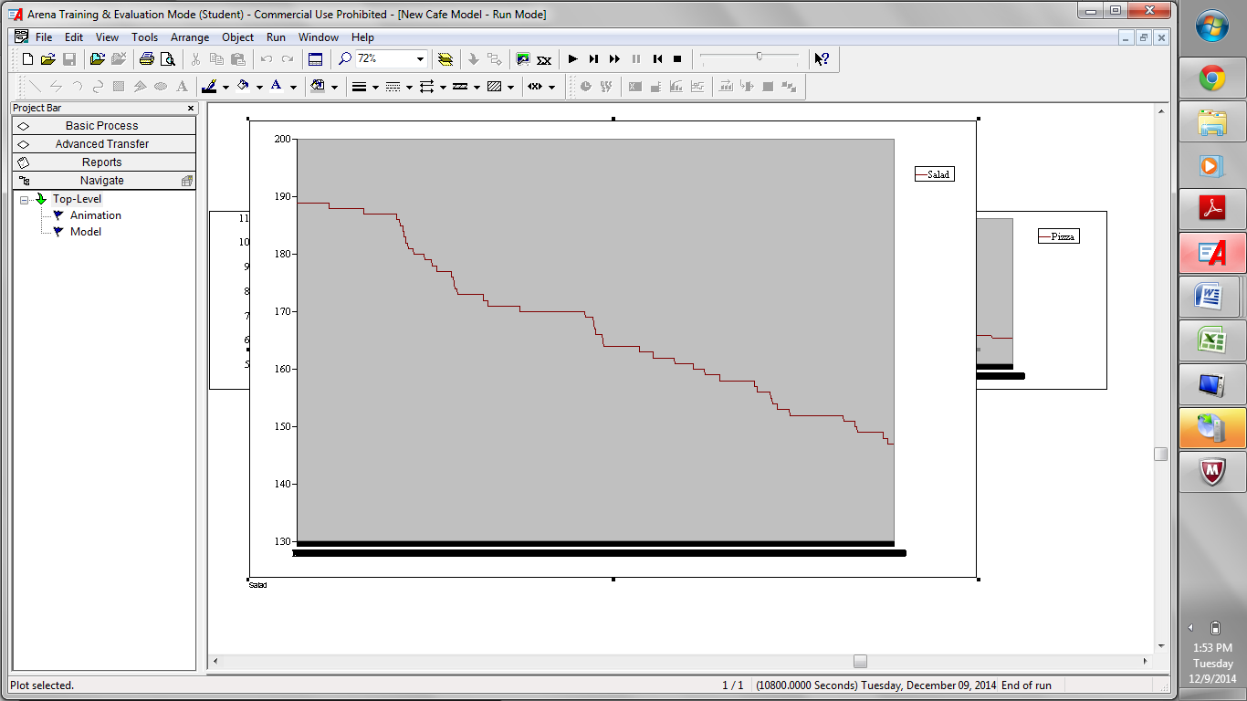

We can see that if we have a full amount of salad, including backup we will not run out. In fact we only use around 40+ servings, so we have way too much excess for the next couple of days.

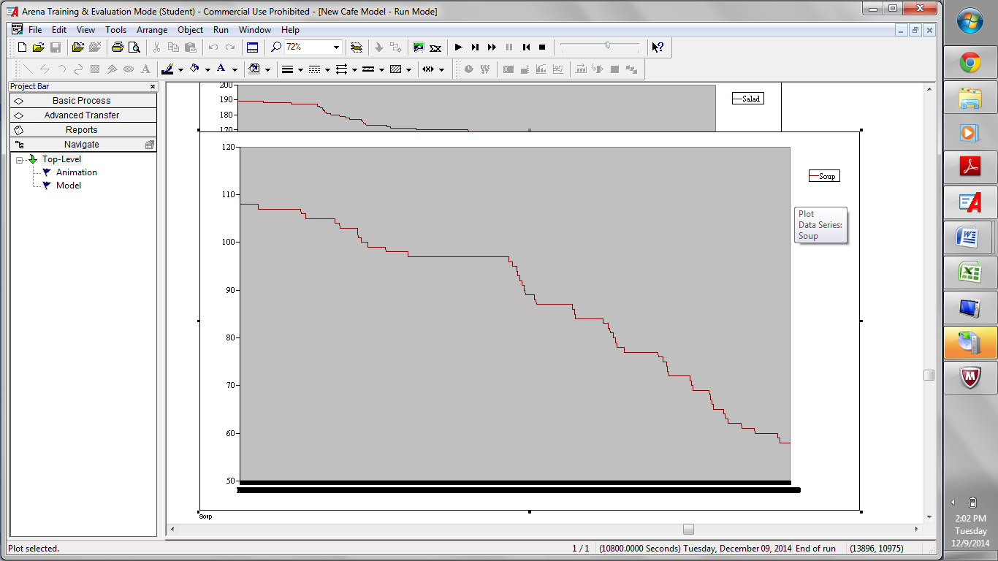

We can see that soup also doesn’t run out, we have about 59 servings left, which includes back up soup. We can see that we have enough food for the next day as well.

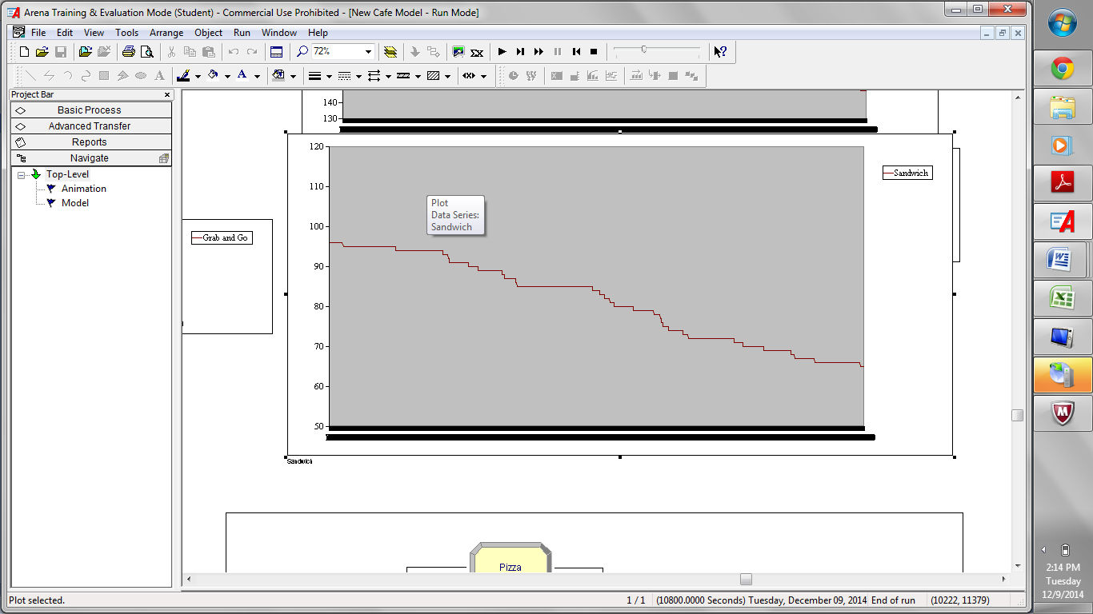

We have around 65 sandwiches left in the system, so there is back up sandwiches for the next day.

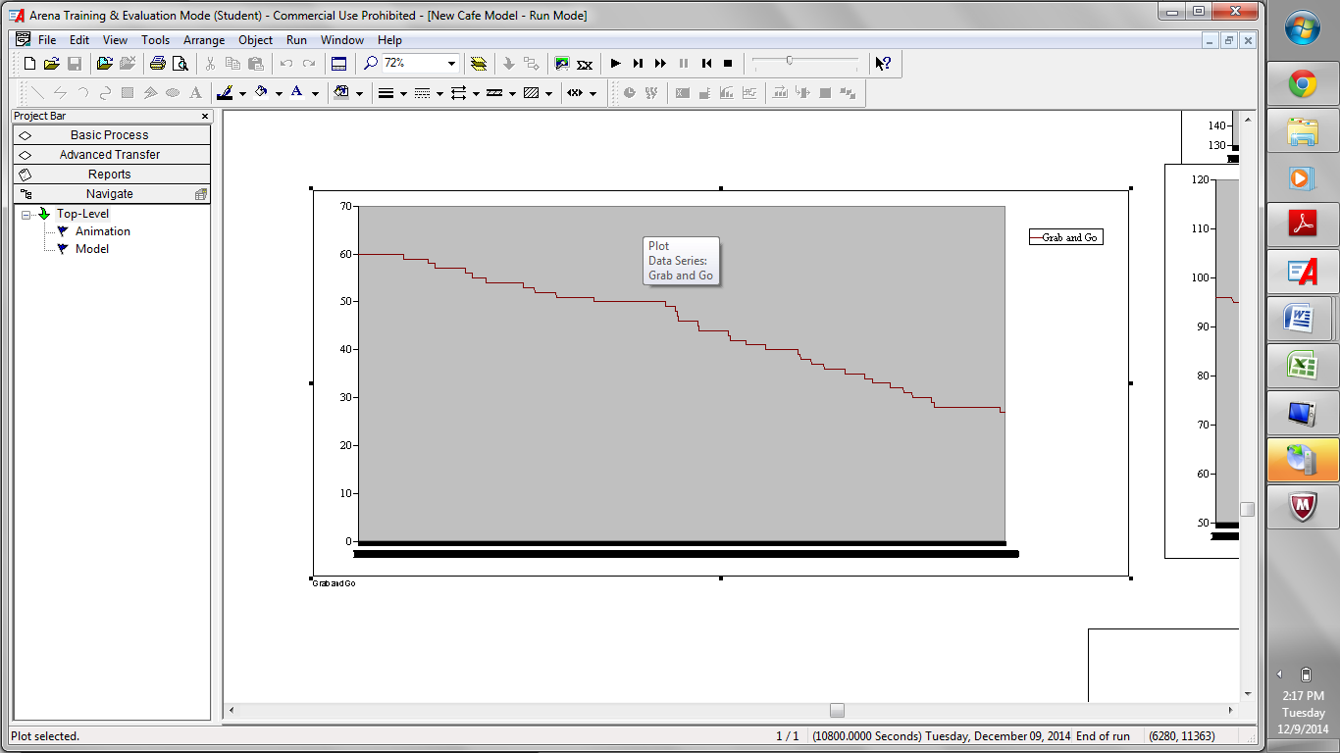

The Grab and Go Level depletes to around 27 servings, the grab and go items are most likely to run out before any of the other items.

Since we have analyzed the queue time, and inventory levels, we can see that our system is well stocked and extremely efficient on any regular day with approximately 355 people coming through during a 3 hour long period.

Developed/Analyzed Alternatives:

1. We can afford to increase the queue time for food servers since it is only one second, so we can reduce the number of food servers.

When the number of food servers is reduced to one in the simulation logic, the average queue time has increased to the value of 17.52 seconds which is a significant increase in time, however, 17 seconds is still not a very long time to wait for items.

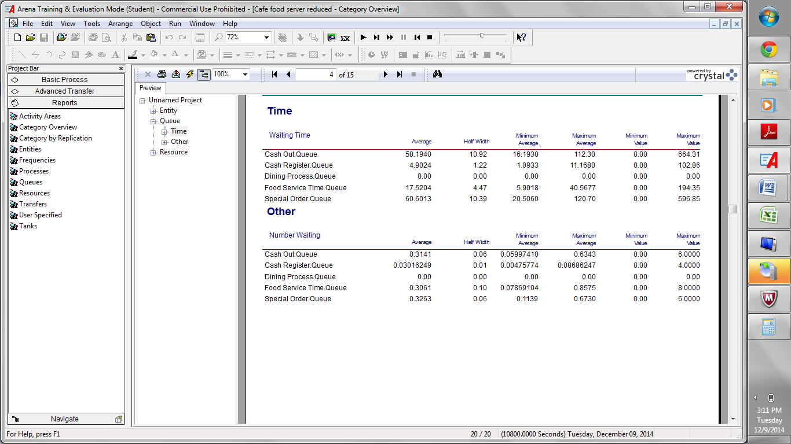

The monetary savings of reducing the number of food servers not including setup and break down time is: (10 dollars an hour)\*(11am-2pm)= 30 dollars

2. The system does not need to be fully stocked on a regular non-busy weekday, the level of initial food stock can be reduced to reduce food waste.

The initial level of food items on a non busy day will be reduced by the following list below:

Pizza initial level: 10 pizzas, which leaves 60 servings of pizza.

Salad initial level: 63 servings, so no back up salad

Soup initial level: 54 servings, no back up soup

Sand initial level: 48 servings, only 1 rack of veggie, 1 rack of meat

GnG initial level: 40 servings

The resulting plots are laid out in the same order as listed above. We can see that the levels do not deplete with the above initial serving sizes.

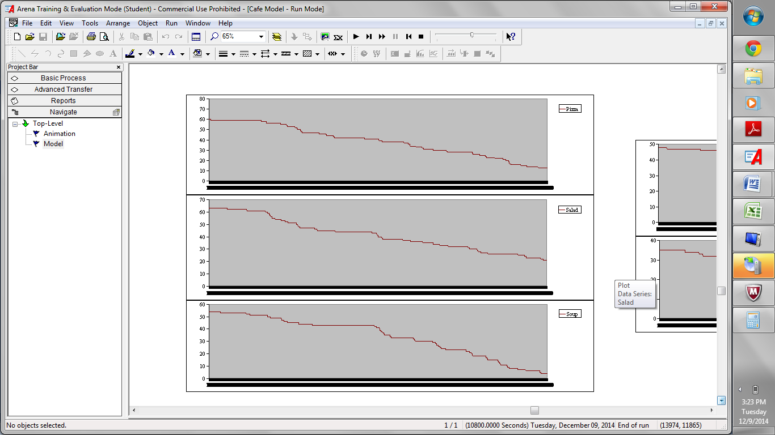 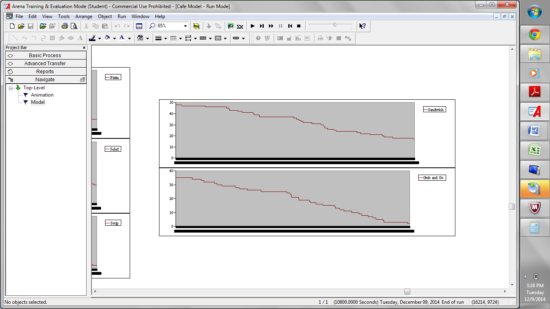

3. We can add a bar cashier to reduce the amount of queue time at the barista station.

Adding a bar cashier costs the following amount: (10 dollars an hour)\*(3 hours in operation)=30 dollars

The average queue time for the cash out: 8.2422 seconds, there is 95% confidence that the range of this number is with in +-3.22 seconds. Special order: 27.2994 seconds and there is a 95% confidence that that the average sits with in +-21.25 seconds of that number. It can be seen that the reduction in the time spent in the queue for cash out and special order is fairly significant when we add a bar cashier. The cash out queue average from the original system has reduced by 39 seconds (47-8), and the special order average queue time has reduced by 22 seconds (49-27).

